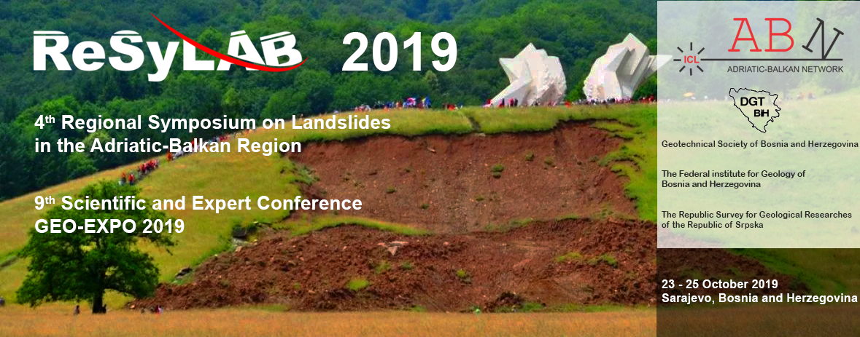

**Invitation**

On behalf of the Geotechnical Society of Bosnia and Herzegovina, The Federal Institute for Geology of Bosnia and Herzegovina and The Republic Survey for Geological Researches of the Republic of Srpska, we are pleased to invite you to take part in the 4th Regional Symposium on Landslides in the Adriatic-Balkan Region - ReSyLAB 2019 and 9th Scientific and Expert Conference GEO-EXPO 2019 in Sarajevo.

ReSyLAB & GEO-EXPO 2019 will be held from 23rd to 25th of October 2019 at the Holiday hotel in Sarajevo, Bosnia and Herzegovina.

The aim is to gather the International Consortium on Landslides Adriatic-Balkan Network (ICL ABN) members, regional geotechnical experts, professionals and researchers from the countries in the Adriatic-Balkan region and world-wide, concerned with landslides, geotechnics, hazard and risks.

We look forward to welcoming you to ReSyLAB & GEO-EXPO 2019 in Sarajevo.

Best Regards,

Prof. dr. Mato Uljarević

President of the Geotechnical Society of Bosnia and Herzegovina

On behalf of Organizing Committee of ReSyLAB & GEO-EXPO 2019

**Symposium & Conference Themes**

The **ReSyLAB & GEO-EXPO 2019** is an opportunity for the scientists, engineers and professionals to present papers and case studies related to:

* landslides in general
* mapping
* geotechnical investigation and monitoring
* environment engineering
* underground structures
* geotechnical hazard and risk
* road infrastructure
* foundations
* landfills

The **ReSyLAB & GEO-EXPO 2019** will be organized by 2 separate sessions. The official language of the ReSyLAB session is English. The official languages of the GEO-EXPO session are Bosnian, Croatian, Serbian and English. Simultaneous translations on English will be organized.

**Important Dates**

|  |  |
| --- | --- |
| Registration  Abstract submission  Abstract acceptance  Full paper submission  Field study tour | November 19, 2018 - October 23 – 24, 2019  June 01, 2019 June 15, 2019 July 15, 2019 October 25, 2019 |

**Abstract and Full Paper Submission**

All symposium & conference participants are invited to submit abstract and the full paper, to be peer- reviewed and published in the symposium proceedings. The keynote lectures and selected papers will be published in two separate books of proceedings:

- Proceedings of the 4th Regional Symposium on Landslides in the Adriatic-Balkan Region

- Proceedings of the 9th GEO-EXPO 2019

Instructions for the preparation of abstract and full paper (4-6 pages) will be

both sent to authors after registration by e-mail and available on the website.

Registration form / Abstract / Full paper / Information /

send to the mail: geotehnika@geotehnika.ba

Download: Registration form / Paper template / Information

<http://www.geotehnika.ba/ReSyLAB_&_GEO-EXPO_2019.html>

**Preliminary ReSyLAB & GEO-EXPO 2019 Programme**

|  |  |  |
| --- | --- | --- |
| **22-23 October 2019** | **24 October 2019** | **25 October 2019** |
| Participant registration  Symposium & Conference opening  Oral presentations  Poster session  Social evening | Oral presentations  The ISL ABN Round table | Field study tour |

**Registration Fees and Deadlines**

The registration fee for all participants is 120 EUR (240 BAM) except for the members of the Geotechnical Society of Bosnia and Herzegovina for whom it is 80 EUR (160 BAM membership has been included). The registration fee includes symposium proceedings, cocktail refreshments and lunch & dinner meals.

Payment instructions:

From abroad, payment in EURO:

Bank: RAIFFEISEN BANK DD BOSNA I HERCEGOVINA

Swift code: RZBABA2S Bank address: Zmaja od Bosne bb, Sarajevo BiH

IBAN: BA391611250000651837

USER: Društvo za geotehniku u BiH (Geotechnical Society of Bosnia and Herzegovina)

USER ACCOUNT ADDRESS: Univerzitetska 2, 75000 Tuzla, BiH

The bank transfer cost is not included in the registration fee.

Domestic payment in BAM:

Raiffeisen Bank dd BiH: 1610250029260097

USER: Društvo za geotehniku u BiH,

CONTACT INFO:

Geotechnical Society of Bosnia and Herzegovina, Univerzitetska 2, 75000 Tuzla,

Bosna i Hercegovina

e-mail: geotehnika@geotehnika.ba,

<http://www.geotehnika.ba/ReSyLAB_&_GEO-EXPO_2019.html>

**Initial Organizing Committee**

Prof. Mato Uljarević

Prof. Bojana Grujić

Prof. Maja Prskalo

Prof. Azra Špago

Prof. Sabid Zekan

Amer Džindo

Hazim Hrvatović

Ferid Skopljak

Dragan Mitrović

Cvjetko Sandić

Sabrina Salković

**Venue**

ReSyLAB 2019 is to be held at the hotel Holiday in the very center of Sarajevo <http://www.hotelholiday.ba/en/>

Discount hotel accommodation: 1/1 single room: 72 BAM (37 EUR) + tax

2/1 double room: 84 BAM (43 EUR) + tax

**GOLD SPONSORS:**

